December 7, 2018

Winooski School District
Office of the Superintendent
60 Normand Street
Winooski, Vermont 05404
(802) 383-6000
www.wsdschools.org
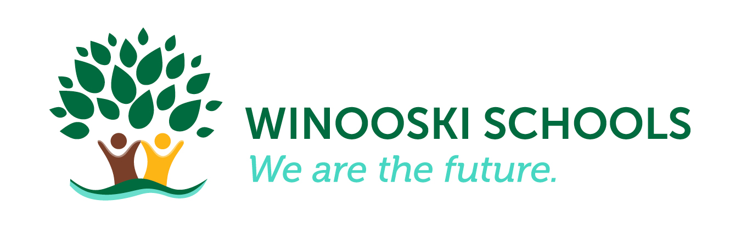
All students will graduate from the Winooski School District (WSD) college and career ready at a cost supported by a majority of the Winooski community. WSD students will lead healthy, productive and successful lives and engage with their local and global community.

Superintendent’s Board Report
Action Items: The Winooski administration recommends that the board approve all of the following action items:

5. Consent Agenda: (5 Minutes)
a) Minutes of Meetings: November 14 and 28, 2018
b) Policy Title: 2.3 Financial Conditions and Activities
- Approval of Bills
c) Policy Title: 2.7 Compensation and Benefits
• Approve Contract – Ann Browning Long Term Sub
d) Policy Title 2.8 Communication and Support to the Board
• Superintendent Report

Discussion & Action Items: Please review backup for the following items.
6. Executive Limitations (Policy Section II): (20 Minutes)
a) Policy Title: 2.4 Financial Planning and Budgeting
- FY20 Budget and Timetable
b) Policy Title 2.6 Asset Protection
- WSD Capital Project Committee Update: Community Engagement Plan
c) Policy Title 2.8 Communication and Support to the Board
- Superintendent Monitoring Report 2.8: Review/Discussion/Approve

7. Board/Management Delegation (Policy Section III:) (20 Minutes)
a) Policy Title 3.1 Unity of Control
- Board Monitoring Report 3.1: Review/Discussion/Approve

8. Governance Processes (Policy Section IV): (60 Minutes)
a) Policy Title: 4.1.b Governing Style: Encouragement of a Diversity of Views
- Student Report to the Board
- FY 20 Budget Session

Curriculum, Instruction & Assessment:

- WSD Capital Project Committee (CPC): Supt. McMannon has continued meeting with key individuals in our community about the project. The committee will meet on Tuesday, December 11th to review updated potential cost reductions and the community engagement plan. Imaj will be here Tuesday and Wednesday, December 12-13 to conduct interviews and create promotional materials.

- WMHS Co-Principal Hiring process: The position was posted on Schoolspring.com on November 5th and will close on January 11th. The Interview Team has been composed and has met twice to review confidentiality, develop a set of desired characteristics and skills and construct interview questions. First round interviews are slated for January 28-February 8 and final interviews including site visits will be February 11-22 culminating in a recommendation to hire to the board at the March 2019 meeting.

- Legislative Work
  - 2018 Education Legislative Reports:
    - 2018 Education Legislative Wrap Up Report #10

WSD Goals
Goal #1: College & Career Readiness
- On November 12th and 13th, eight WSD teachers attended a training on “Collaboration and Co-Teaching for English Language Learners.” The teachers who attended are classroom and ELL teacher pairs who co-teach content area classes to best support our intermediate/advanced ELL and native English speaking students. Teachers walked away with a lot of new strategies to use when planning and teaching together.
- Journey 7/8 held its Culminating Event for their fall Expedition, Government Comes Alive. At the O’Brien Center, students presented their designs for new uses of two green spaces in downtown Winooski to City Manager Jessie Baker, and several other officials.
- The week of December 3rd - 7th was the Hour of Code. Coding is similar to what used to be called programing. Exposing our students to coding, even if just for an hour, gives them the opportunity to learn about something that they use each and every day. While the concept of coding is complicated, the Hour of Code has made it super easy to implement in classrooms. During the Hour of Code week, every JFK class did an hour of coding. If you would like to see what it is all about and do some of the activities go to www.hourofcode.com for more information.

Goal #2: Healthy, Productive & Successful Lives
- All WMHS staff participated in a training on Implicit Bias from ISP International on our November early release day. This professional development followed up on work started during August preservice. This training invited staff to dig deeply into their beliefs, especially their subconscious or implicit biases. There were a lot of powerful large and small group conversations that took place and we will continue this work at our early release day in March.
- WMS is close to finishing the 2018-19 Social Contract. The General Assembly met and brought revisions from each advisory, students made changes and presented back to advisories. Once 100% consensus is reached the document will be printed, signed and posted.
- JFK students continue to work on a social skill each week as an entire school. During morning meeting, every class discusses the weekly social skill, and students are acknowledged with High 5’s when they use the social skill throughout the day. So far students have learned about things like asking for help, listening, accepting no, and compliments.

Goal #3: Local & Global Community Engagement
- The JFK Newcomer class hosted their annual Thanksgiving dinner for 13 of our recently arrived ELL students to teach them about the Thanksgiving holiday and give them a chance to try all of the traditional Thanksgiving dishes.
- Kirsten Kollgaard, Director of ELL & Curriculum, presented about the needs of ELL students to UVM’s Department of Education at their November faculty meeting. She was invited to speak to faculty about what preservice teachers need to know about supporting ELLs and how faculty can better prepare preservice teachers to work with them. She presented with Miriam Ehtesham-Cating, Burlington ELL Director, and Jim McCobb, Title III/ELL Coordinator for the Vermont Agency of Education.
- WMHS students performed Alice in Wonderland. This was the first collaboration between WMHS and Very Merry Theatre.
- John Tapper, Associate Professor of Elementary Education at St. Michael's College, teaches a science practicum class. The students in his class is put together interactive inquiry investigations. They brought them to JFK on Friday, December 17th and our 1st and 2nd grade classes moved through their "mobile museum". It was an inquiry based, super fun science experience for our students.

Finance/Operations
- The team from Fothergill Segale & Valley has completed their field work and issued a draft audit. A final audit document will be ready for the January board meeting.
- Rebecca Goulet attended a conference designed by the Agency of Education regarding the the new accounting software that the AOE has chosen for the statewide system called eFinance. eFinance is a module of PowerSchool.
- At the end of November our fund balance for FY19 is favorably forecasted at $69K or .41% of the voter-approved budget. We have made assumptions for several open Instructional Assistant positions and Health Reimbursement Accounts.
- The budget for Health Reimbursement Arrangements (HRA) for FY19 is $478,374. We have expended $118K or 24% of the budget.
- The projected balance of the Capital Reserve Fund is currently $360K.

